sklearn.model_selection.**train_test_split**(*arrays, **options)

https://scikit-learn.org/stable/modules/generated/sklearn.model_selection.train_test_split.html

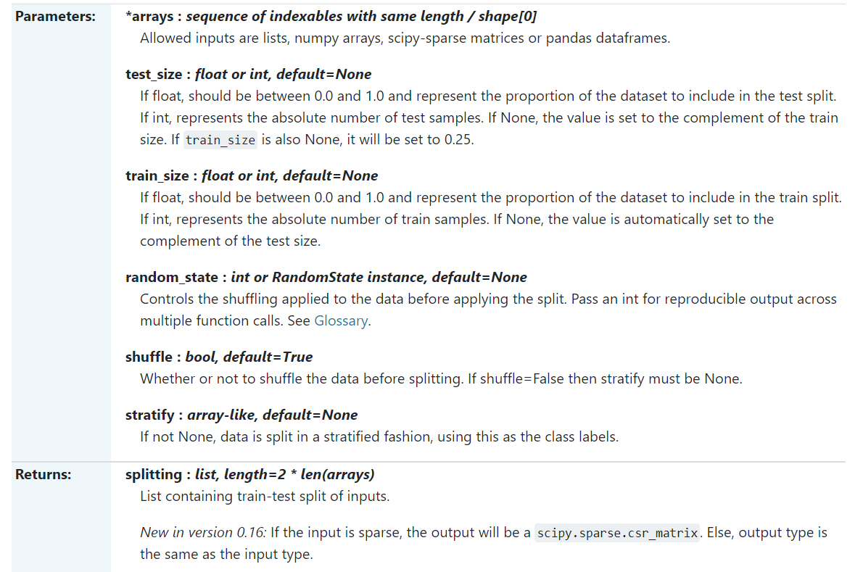

sklearn.model_selection.**cross_val_score**(estimator, X, y=None, *, groups=None, scoring=None, cv=None, n_jobs=None, verbose=0, fit_params=None, pre_dispatch='2*n_jobs', error_score=nan)<https://scikit-learn.org/stable/modules/generated/sklearn.model_selection.cross_val_score.html>

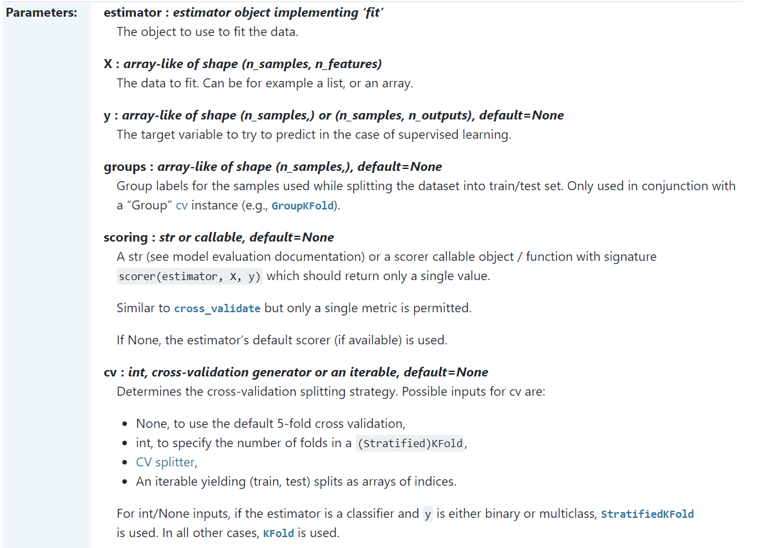

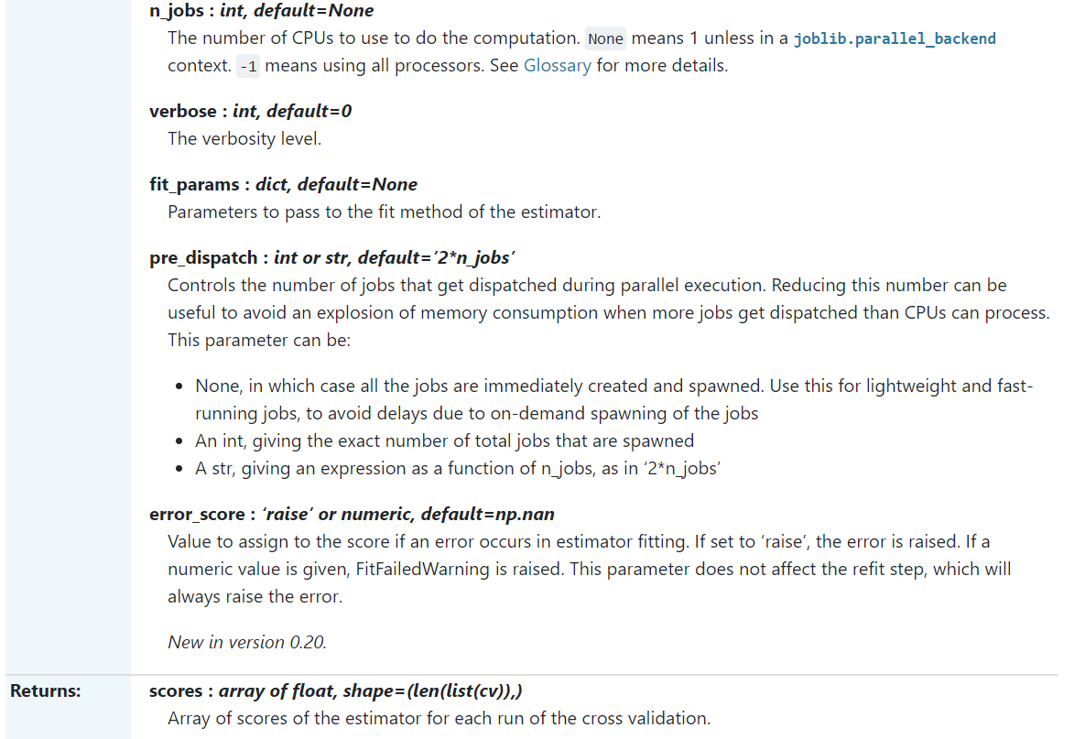

class sklearn.model_selection.**GridSearchCV**(estimator, param_grid, *, scoring=None, n_jobs=None, iid='deprecated', refit=True, cv=None, verbose=0, pre_dispatch='2*n_jobs', error_score=nan, return_train_score=False)

